--Create an Instance with a Start up Script which installs apache server and adds an index.html file to the Instance

--The Start up Code is as Follows--

#!/bin/bash
sudo apt get update
sudo apt -y install apache2
sudo mkdir -p /var/www/html/webserver
sudo chown ubuntu /var/www/
sudo chmod -R o+r /var/www/
sudo chown -R 755 /var/www/
echo "<html><body><h1> This is the first website. </h1></boody></html>" > /var/www/html/webserver/index.html
sudo cp /etc/apache2/sites-available/000-default-conf /etc/apache2/sites-available/webserver.config

--Now Create an Image of the Above Instance.

--Now Create A Load Balancer

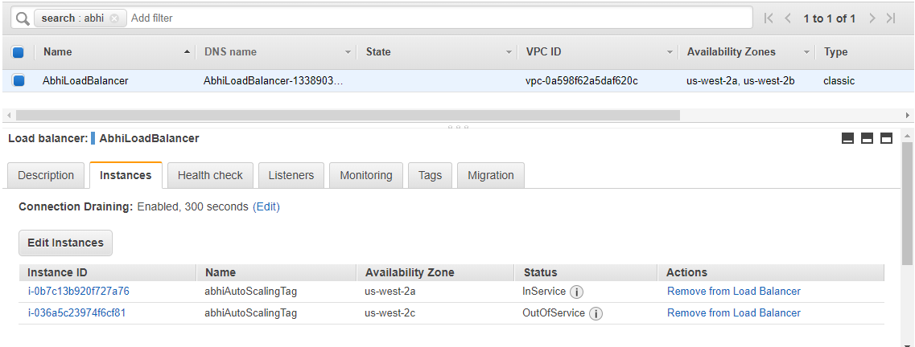

Here is the Listener Configurarion

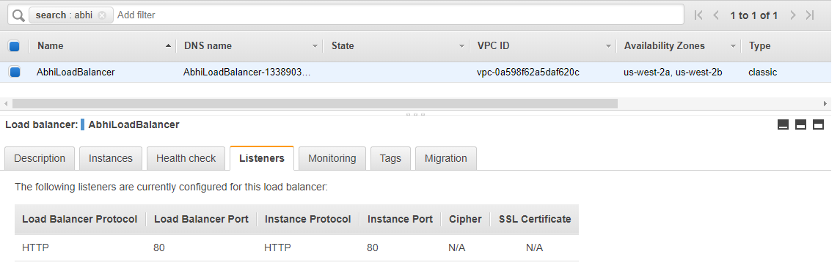

--Create a Launch Configuration using the AMI Image which you Created.

--Create An Auto-Scaling Group by providing all the necessary details such as Scaling Policies, Instances and all…

--Link the Load Balancer To The Auto-Scaling Group.

Thats it Our Web Server is Done with!!

--Here is the Screen Shot of the Security Groups

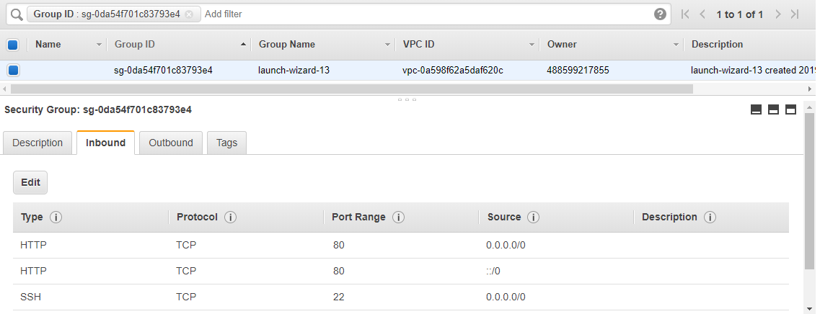

--Here is the pic of the website

